TASK FLOW DOCUMENTATION
Queue Management System
Contents
TASK FLOW DOCUMENTATION 1
1. Introduction 2
2. Objective 2
3. Actors 2
4. Preconditions 3
5. Main Task Flow 4
Step 1: Welcome Screen 6
Step 2: Select Service 6
Step 3: Enter Details 7
Step 4: Queue Confirmation 7
Step 5: Wait in Queue 8
Step 6: Service Notification 8
Step 7: Service Completion 9
6. Alternative Flows 10
A. Missing Details 10
C. Queue Cancellation 10
D. Notification Missed 10
7. Postconditions 11
8. Benefits of the Task Flow 11
9. Task Flow Summary 11
10. Conclusion 12

1. Introduction
This document describes the complete task flow of the Queue Management System. The system is designed to simplify the process of accessing services by allowing users to join a queue digitally rather than waiting in physical lines. It provides real-time updates on queue status, estimated waiting time, and service notifications, thereby improving efficiency and enhancing the user experience.
The task flow outlines every interaction between the user and the system, beginning from launching the application to the completion of the requested service.

2. Objective
The objective of this task flow is to:
- Enable users to join a service queue electronically.
- Allow users to select the service they require.
- Collect the necessary user information.
- Confirm successful queue registration.
- Notify users when it is their turn.
- Complete the service process while collecting customer feedback.

3. Actors
Actor | Role
User | Joins the queue and receives the requested service.
Queue Management System | Processes queue requests, manages queue order, and sends notifications.
Service Provider | Delivers the requested service to the user.

4. Preconditions
Before starting the task flow:
- The Queue Management System is operational.
- The user has access to the application.
- Available services have already been configured.
- The user has internet connectivity (for online access).

5. Main Task Flow
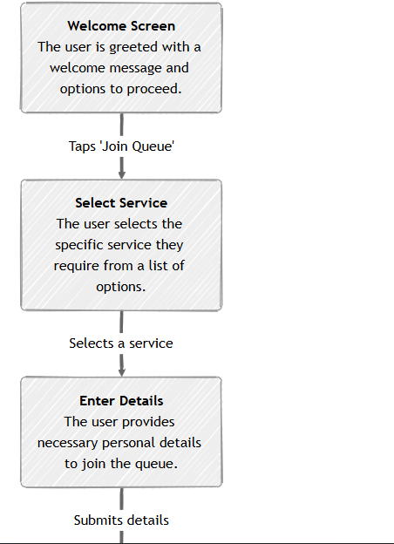
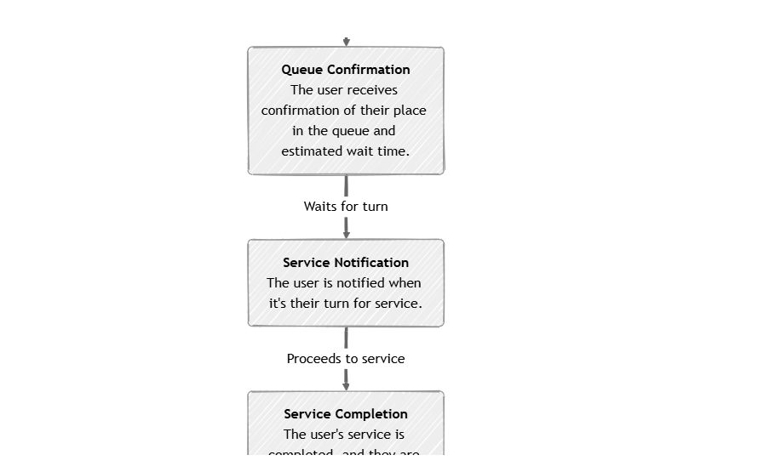
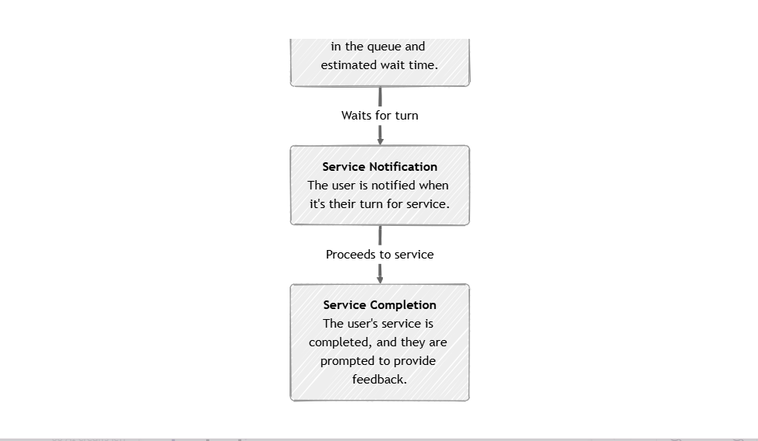

Step 1: Welcome Screen
Description
When the application launches, the user is presented with a welcome screen containing introductory information and navigation options. This serves as the entry point into the queue management process.
User Action
- Opens the application.
- Reads the welcome message.
- Clicks the Join Queue button.
System Response
- Displays the list of available services.
Output
The user proceeds to the service selection page.

Step 2: Select Service
Description
The system displays all available services offered by the organization. The user selects the service they require before joining the queue.
User Action
- Browse available services.
- Select the desired service.
System Response
- Records the selected service.
- Redirects the user to the details entry page.
Output
The selected service is saved temporarily.

Step 3: Enter Details
Description
The user provides the personal information required for queue registration.
Typical information may include:
- Full Name
- Phone Number
- Email Address (optional)
- Student/Staff ID (if applicable)
User Action
- Fill in the required details.
- Click Submit.
System Response
- Validates all required fields.
- Creates a new queue entry.
Output
The user is successfully added to the queue.

Step 4: Queue Confirmation
Description
After successful registration, the system confirms that the user has joined the queue.
The confirmation page displays:
- Queue Number
- Selected Service
- Estimated Waiting Time
- Current Queue Position
User Action
- View queue information.
- Wait for notification.
System Response
- Stores the queue record.
- Continuously updates queue status.
Output
Queue registration completed successfully.

Step 5: Wait in Queue
Description
The user remains in the queue while the system processes other customers ahead.
User Action
- Wait.
System Response
- Updates queue positions.
- Recalculates waiting time.
- Monitors queue progression.
Output
The user remains active in the queue.

Step 6: Service Notification
Description
When the user's turn arrives, the system sends a notification informing them to proceed for service.
Notifications may include:
- In-app notification
- SMS
- Email
- Display board notification
User Action
- View notification.
- Proceed to the service point.
System Response
- Changes queue status to Now Serving.
- Directs the user to the appropriate service desk.
Output
The user is ready to receive service.

Step 7: Service Completion
Description
The requested service is delivered successfully.
After completion, the system marks the queue entry as completed and optionally requests customer feedback.
User Action
- Receive service.
- Submit feedback (optional).
System Response
- Marks queue as completed.
- Stores customer feedback.
- Ends the session.
Output
The transaction is successfully completed.

6. Alternative Flows

A. Missing Details
If required information is missing:
- The system displays validation errors.
- The user is prompted to complete all mandatory fields.
- Submission is not accepted until all fields are valid.

B. Invalid Contact Information
If the phone number or email is invalid:
- The system displays an error message.
- The user corrects the information.
- Registration continues.

C. Queue Cancellation
If the user decides not to continue:
- The user exits the application.
- No queue record is created.

D. Notification Missed
If the user fails to respond when called:
- The system may skip the queue position.
- The user may need to rejoin the queue according to organizational policy.

7. Postconditions
Upon successful completion:
- The requested service has been delivered.
- Queue status changes to Completed.
- Queue statistics are updated.
- Feedback (if provided) is stored in the database.

8. Benefits of the Task Flow
The task flow provides several advantages:
- Reduces waiting time.
- Eliminates long physical queues.
- Improves customer satisfaction.
- Enhances service efficiency.
- Enables real-time queue monitoring.
- Provides accurate waiting time estimates.
- Supports digital notifications.
- Collects customer feedback for continuous improvement.

9. Task Flow Summary
Step | User Action | System Response
1 | Open application | Display Welcome Screen
2 | Click Join Queue | Display available services
3 | Select service | Save selected service
4 | Enter personal details | Validate and register queue
5 | Submit information | Generate queue number
6 | Wait | Update queue status
7 | Receive notification | Call user for service
8 | Receive service | Mark service as completed
9 | Submit feedback (optional) | Store feedback and end session

10. Conclusion
The Queue Management System task flow provides a streamlined, user-friendly approach to managing customer queues digitally. From the welcome screen to service completion, each stage is designed to minimize waiting times, improve communication, and ensure efficient service delivery. By incorporating queue confirmation, real-time notifications, and optional customer feedback, the system enhances both the user experience and organizational service management. This workflow forms a solid foundation for implementing an effective and scalable digital queue management solution.

